Lab: Gosu for Queries

In this lab, you will enhance the ABContactSummary class to make use of queries.

Requirements

This lab requires that you use TrainingApp 8.0, Guidewire Studio 8.0, and Chrome as your web browser. Start Guidewire Studio for Training App. Debug the Server.

To view, edit, and delete various contacts, log in to TrainingApp as Super User. The default URL for TrainingApp is <http://localhost:8880/ab/ContactManager.do>. The login/password for Super User is su/gw.

1. Query the assigned user contact count

In this exercise, you will modify and enhance the ABContactSummary class. Additional requirements appear in yellow highlighted text:

Tasks

1. Add an additional property to ABContactSummary
2. ExternalID (an integer).
3. ContactID (a String).
4. Name (a String).
5. NumCheckingAccounts (an integer).
6. AssignedUserWorkload (an integer).
7. Create the initializeExternalID() method that meets the following criteria:
8. If the summary's ExternalID is 0, set the ExternalID to a unique integer no less than 1000, otherwise, do nothing.
9. Create the loadSummaryData() method that meets the following criteria:
10. Takes an input parameter of the type entity.ABContact.
11. Set the summary's ContactID to the ABContact's public ID.
12. Set the summary's Name to the ABContact's DisplayName field.
13. Use ABContact's BankAccounts array's where() method to determine the number of accounts that are checking accounts.
14. Set the summary's NumCheckingAccounts to the number of accounts where the type is checking.
15. For the user assigned to the target contact, query the total number of contacts assigned to the given user.
16. Set the summary's AssignedUserWorkload to this total. If the contact's assigned user is null, set the AssignedUserWorkload field to 0.
17. Create the getConcatenatedSummary() method that meets the following criteria:
18. Returns a String that contains the value of all five properties as a comma-delimited list.

Verification

You will verify the behavior of the instance of a class.

1. Assign a User to an ABContact
2. In TrainingApp, navigate to the contact that you worked on in the previous lab, for instance, William Andy.
3. On the summary screen, select an Assigned User.

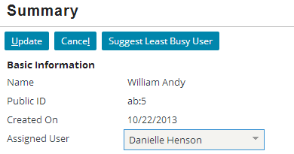

1. Navigate to Administration
2. Navigate to the Administration tab's Contact Assignment screen.
3. Note the number of contacts assigned to the user you previously selected.

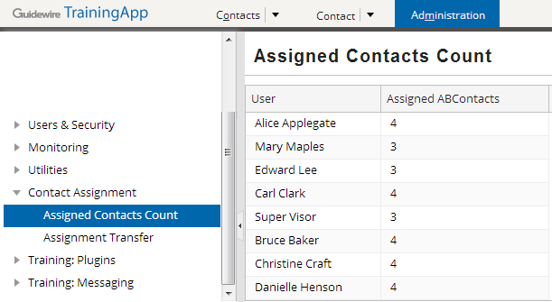

1. Generate console output for ABContactSummary using Gosu Scratchpad
2. In Guidewire Studio, open Gosu Scratchpad.
3. Using ta.QueryUtil.findContact(), create a variable that references your contact.
4. Create a new ABContactSummary.
5. Execute the initializeExternalID() method.
6. Execute the loadSummaryData() method using the given contact.
7. Retrieve and print the output of the getConcatenatedSummary () method.
8. Verify the output
9. Verify that the output in the Debug Console has five delimited values.

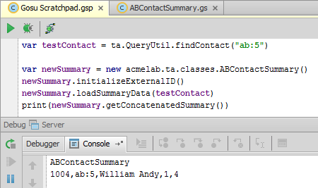

|  |  |
| --- | --- |
|  | Stop and ask your instructor to review your completed lab. |